UNITED STATES SECURITIES AND EXCHANGE COMMISSION

Washington, D.C. 20549

FORM 8-K

CURRENT REPORT

Pursuant to Section 13 OR 15(d) of the Securities Exchange Act of 1934

Date of report (Date of earliest event reported): June 14, 2023

ClearOne, Inc.

(Exact name of registrant as specified in its charter)

Delaware | 001-33660 |  |  |  |  |  |  | 87-0398877
(State or Other Jurisdiction of Incorporation) |  | (Commission File Number) |  |  |  |  |  | (I.R.S. Employer Identification No.)
5225 Wiley Post Way, Suite 500, Salt Lake City, Utah |  |  |  |  |  |  |  | 84116
(Address of principal executive offices) |  |  |  |  |  |  |  | (Zip Code)
 |  |  | +1 (801) 975-7200
(Registrant’s telephone number, including area code)

Not applicable

(Former name or former address, if changed since last report)

Check the appropriate box below if the Form 8-K filing is intended to simultaneously satisfy the filing obligation of the registrant under any of the following provisions:

- Written communications pursuant to Rule 425 under the Securities Act (17 CFR 230.425)

- Soliciting material pursuant to Rule 14a-12 under the Exchange Act (17 CFR 240.14a-12)

- Pre-commencement communications pursuant to Rule 14d-2(b) under the Exchange Act (17 CFR 240.14d-2(b))

- Pre-commencement communication pursuant to Rule 13e-4© under the Exchange Act (17 CFR 240.13e-4©)

Indicate by check mark whether the registrant is an emerging growth company as defined in Rule 405 of the Securities Act of 1933 (§230.405 of this chapter) or Rule 12b-2 of the Securities Exchange Act of 1934 (§240.12b-2 of this chapter). Emerging growth company ☐

If an emerging growth company, indicate by check mark if the registrant has elected not to use the extended transition period for complying with any new or revised financial accounting standards provided pursuant to Section 13(a) of the Exchange Act. ☐

Securities Registered Pursuant to Section 12(b) of the Act:

 | Title of each class |  | Trading Symbol(s) |  |  | Name of each exchange on which registered
Common Stock, $0.001 |  |  |  | CLRO |  | The NASDAQ Capital Market

Item 7.01 Regulation FD Disclosure

Beginning on June 14, 2023, ClearOne, Inc. (the “Company”) will participate in investor meetings and the Emerging Growth Conference during which members of the Company’s management will make presentations to investors. A copy of the Company’s investor presentation is furnished herewith as Exhibit 99.1.

Limitation of Incorporation by Reference

In accordance with General Instruction B.2. of Form 8-K, this information, including Exhibit 99.1 furnished herewith, is furnished pursuant to Item 7.01 and shall not be deemed to be “filed” for the purpose of Section 18 of the Securities Exchange Act of 1934, as amended (the “Exchange Act”), or otherwise subject to the liabilities of that section, nor shall it be incorporated by reference into a filing under the Securities Act of 1933, as amended (the “Securities Act”), or the Exchange Act. The information in this Item 7.01 of this Current Report on Form 8-K (including the exhibit hereto) will not be deemed an admission as to the materiality of any information required to be disclosed solely to satisfy the requirements of Regulation FD.

Cautionary Statements

This Current Report on Form 8-K, including the exhibits furnished herewith, contains “forward-looking statements” within the meaning of Section 27A of the Securities Act and Section 21E of the Exchange Act. Such forward-looking statements relate to, without limitation, our future economic performance, plans and objectives for future operations and projections of revenue and other financial items. Forward-looking statements can be identified by the use of words such as “may,” “will,” “plan,” “potential,” “project,” “should,” “expect,” “anticipate,” “estimate,” “target,” “continue” or comparable terminology. Forward-looking statements are inherently subject to certain risks, trends and uncertainties, many of which we cannot predict with accuracy and some of which we might not even anticipate. Although we believe that the expectations reflected in such forward-looking statements are based upon reasonable assumptions at the time made, we can give no assurance that such expectations will be achieved. Future events and actual results, financial and otherwise, may differ materially from the results discussed in the forward-looking statements as a result of various factors, including those listed in Exhibit 99.1 on pages 2 and 3 and incorporated by reference herein. Readers are cautioned not to place undue reliance on these forward-looking statements. Unless required by U.S. federal securities laws, we do not intend to update any of the forward-looking statements to reflect circumstances or events that occur after the statements are made or to conform the statements to actual results. The information contained in this Current Report on Form 8-K, including the exhibit filed herewith, should be viewed in conjunction with the consolidated financial statements and notes thereto appearing in the Company’s Annual Reports on Form 10-K and Quarterly Reports on Form 10-Q.

In connection with the foregoing, the Company hereby furnishes the following documents:

Item 9.01 | Financial Statements and Exhibits
(d) Exhibits
Exhibit Number |  |  |  | Exhibit Title
99.1 |  |  | Investor Presentation.
104.1 |  |  | The cover page from this Current Report on Form 8-K, formatted in Inline XBRL.

SIGNATURES

Pursuant to the requirements of the Securities Exchange Act of 1934, the registrant has duly caused this report to be signed on its behalf by the undersigned hereunto duly authorized.

 | CLEARONE, INC.
Date: June 14, 2023 | By: /s/ Narsi Narayanan
 |  | Narsi Narayanan
Chief Financial Officer (Principal Accounting and Principal Financial Officer)



1

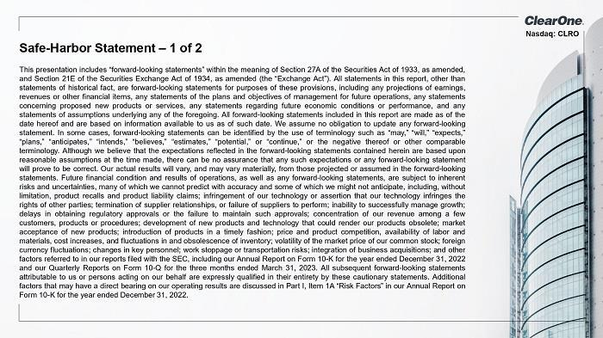

2

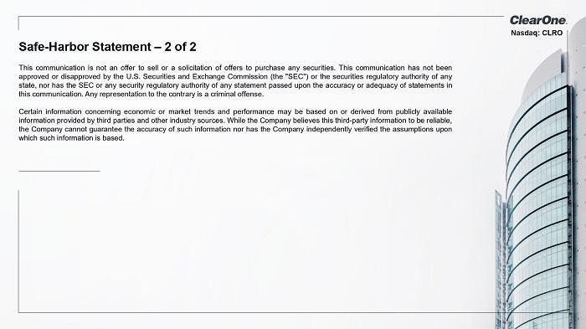

3



4

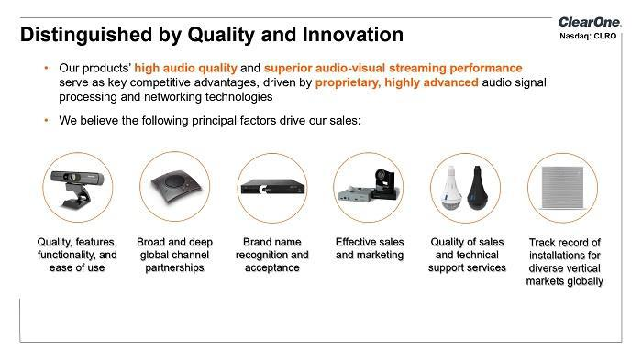

5

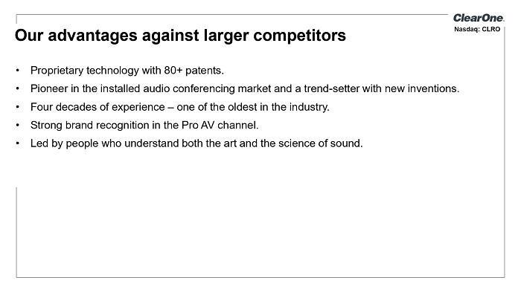

6

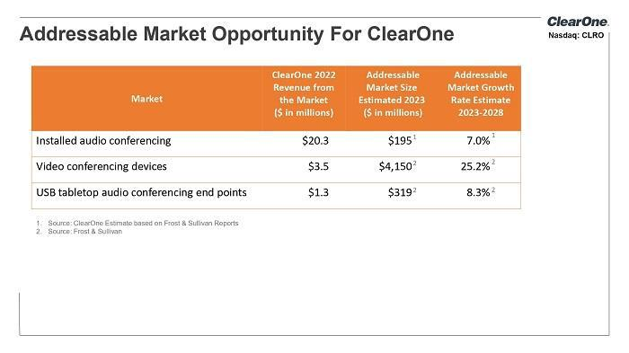

7



8

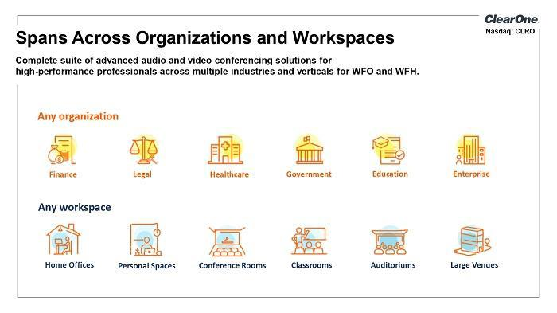

9

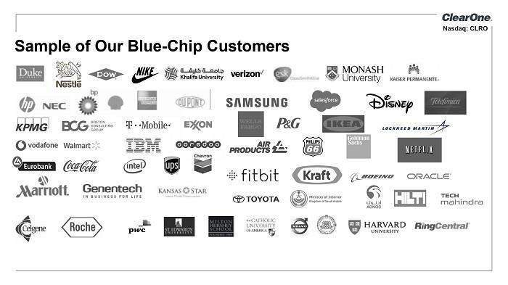

10

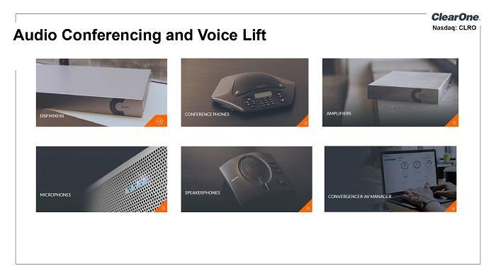

11

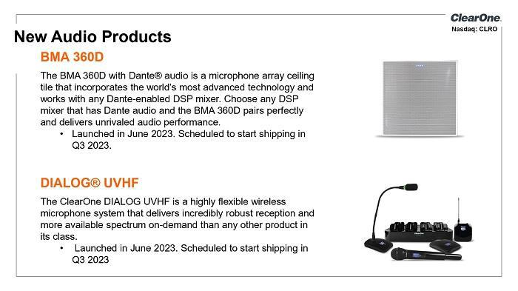

12

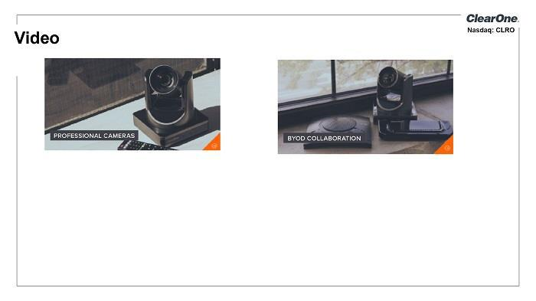

13

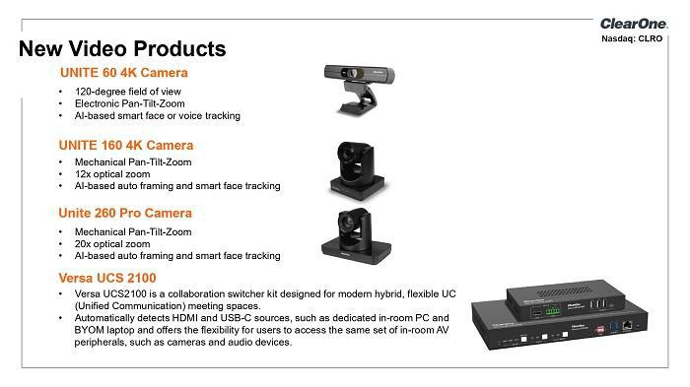

14

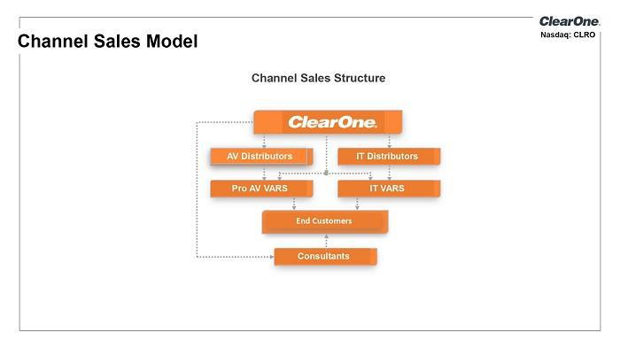

15

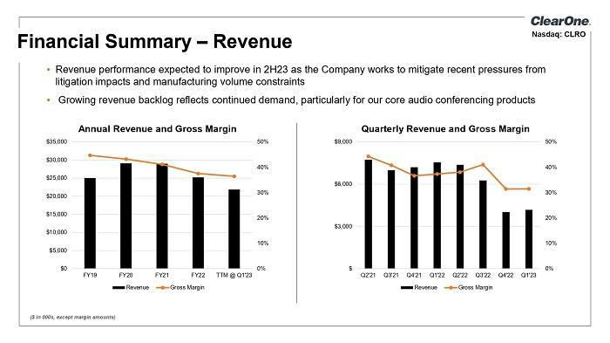

16

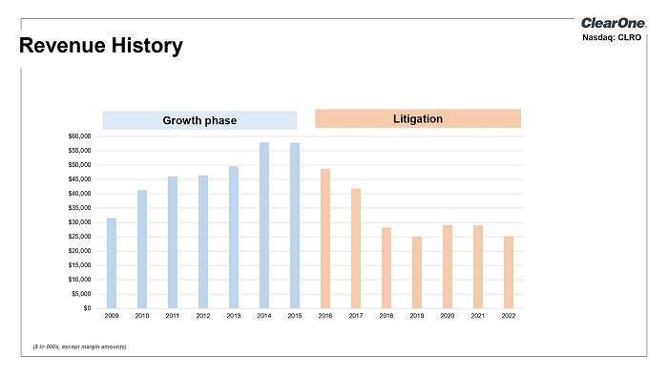

17

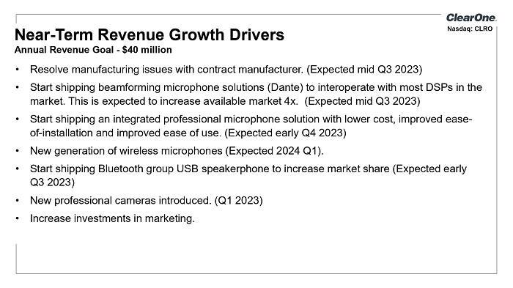

18

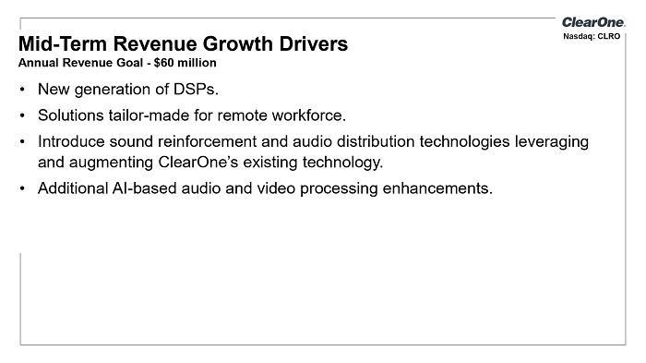

19

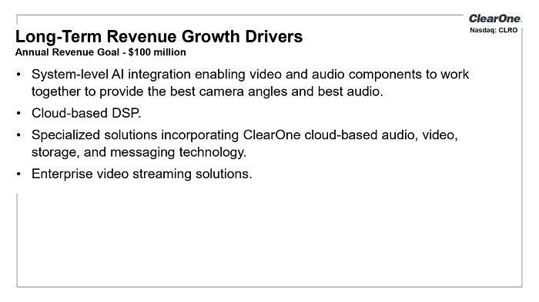

20

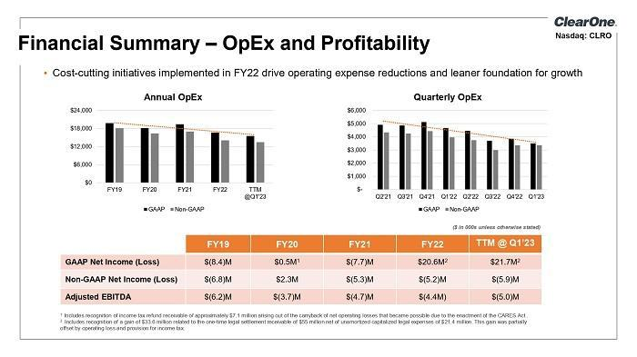

21

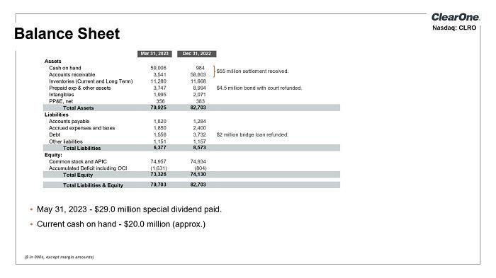

22

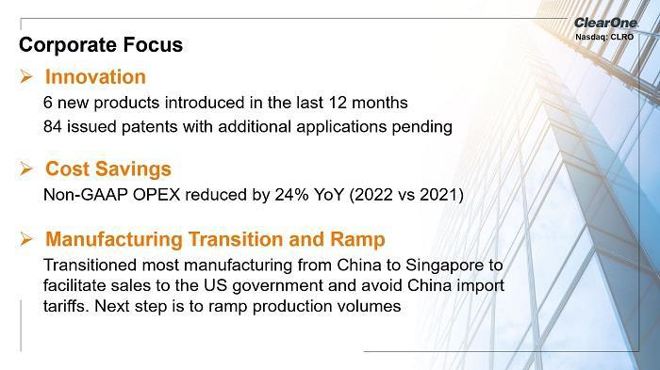

23

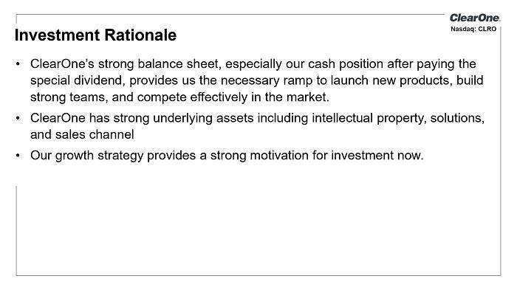

24

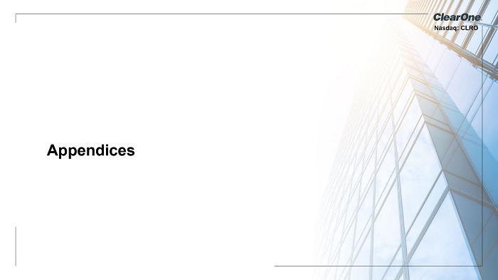

25

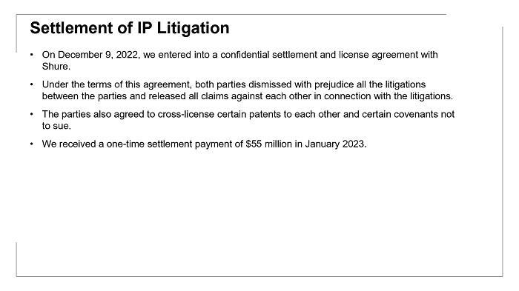

26

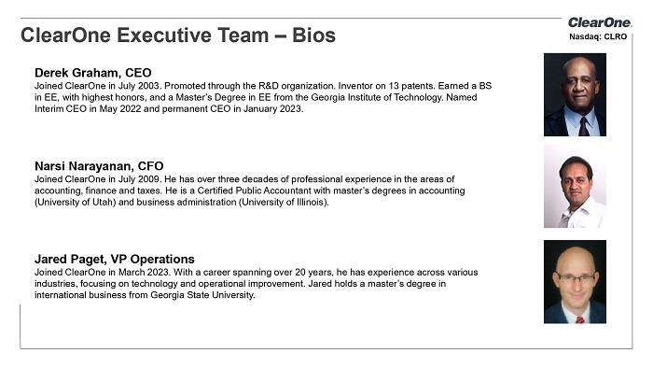

27

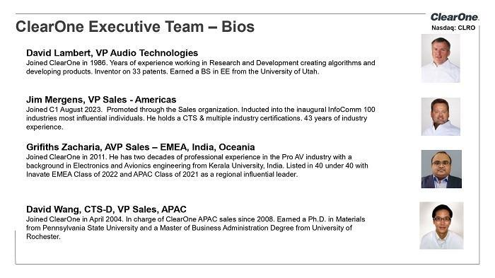

28

29



30

