UNITED STATES

SECURITIES AND EXCHANGE COMMISSION
WASHINGTON, DC 20549

SCHEDULE 14A

(Rule 14a-101)

SCHEDULE 14A INFORMATION

Proxy Statement Pursuant to Section 14(a) of the

Securities Exchange Act of 1934

Filed by the Registrant ☒ Filed by a Party other than the Registrant ☐

Check the appropriate box:

- Preliminary Proxy Statement.

- Confidential, for Use of the Commission Only (as permitted by Rule 14a-6(e)(2)).

- Definitive Proxy Statement.

- Definitive Additional Materials.

- Soliciting Material Pursuant to §240.14a-12.

ClearOne, Inc.

(Name of Registrant as Specified in its Charter)

(Name of Person(s) Filing Proxy Statement, if other than Registrant)

Payment of Filing Fee (Check the appropriate box):

- No fee required.

- Fee computed on table below per Exchange Act Rules 14a-6(i)(4) and 0-11.

  - Title of each class of securities to which transaction applies:

  - Aggregate

  - Per unit price or other underlying value of transaction computed pursuant to Exchange Act Rule 0-11 (set forth the amount on which the filing fee is calculated and state how it was determined):

  - Proposed maximum aggregate value of transaction:

  - Total fee paid:

- Fee paid previously with preliminary materials.

- Check box if any part of the fee is offset as provided by Exchange Act Rule 0-11(a)(2) and identify the filing for which the offsetting fee was paid previously. Identify the previous filing by registration statement number, or the form or schedule and the date of its filing.

  - Amount Previously Paid:

  - Form, Schedule or Registration Statement No.:

  - Filing Party:

  - Date Filed:

Dear Fellow Shareholders:

It is time to vote your ClearOne proxy. You have less than fifteen days to have your voice heard.

ClearOne is on a roll thanks to the support and trust of you, our shareholders; the guidance of our board of directors; the vision and leadership of management; the enthusiasm of our partners; and, of course, the creative energy of our employees. We are delivering profitable growth and solid returns by managing our business with a relentless focus on operational excellence, product innovation and prudent use of hard-earned capital.

We are growing wealth for our shareholders:
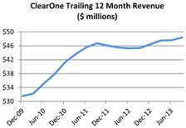

- We grew revenues to $48.4 million in 2013 (twelve months ended September 30, 2013) from $35.7 million in 2009 (twelve months ended December 31, 2009), while maintaining gross margins of about 60% and consistently generating positive cash flow.

- Strategic acquisitions of VCON, NetStreams and MagicBox and their complementary video and network technologies fortified our flagship voice conferencing solutions, making ClearOne a player in the growing $5+ billion video communications market.

- Early this year, ClearOne was awarded damages of $45 million related to auction rate securities sold to the company leaving us with approximately $24.4 million after legal fees and taxes. Soon after the award, the Board authorized the repurchase of up to $10 million of ClearOne stock, and we have repurchased $2.8 million so far. This is only the latest in repurchases—since our NASDAQ relisting in 2006, we have repurchased nearly $20 million or about 30 percent of ClearOne outstanding stock.
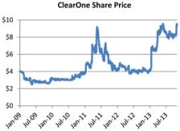

We have the right strategy to continue this momentum:

We are evaluating options to invest to grow our share price and revenue while expanding our footprint in the audio visual industry through strategic acquisitions and internal investments. With our current cash position, a debt-free balance sheet and a demonstrated ability to generate growth, we believe our focused and prudent strategy will drive additional growth and wealth for all stakeholders.

Our current strategy is working thanks to the support of ClearOne’s management team, employees, board of directors and shareholders. To continue implementing this strategy, it is critical that we have the ongoing support of our fellow shareholders. The time is NOW to vote FOR management’s recommendations and FOR ClearOne’s continued growth. I urge you to vote FOR the Board’s recommendations on your proxy to maintain our growth and preserve your power as a shareholder.

I am also pleased to report that the largest and most influential proxy advisory service – Institutional Shareholder Services (ISS) – has endorsed the Board’s proposals on every issue we consider key to the future of the company.

Please vote today. The deadline to vote for the future of your company is less than fifteen days away. Exercise your right to vote. You are important regardless of the number of shares you own. Do not delay.

You are invited to attend our Annual Meeting, scheduled to be held at ClearOne’s corporate offices on December 3, 2013 at 9 a.m. local time. Our offices are located at 5225 Wiley Post Way, Suite 500, Salt Lake City, Utah 84116.

Sincerely,

Zee Hakimoglu

Chairman, President and Chief Executive Officer

ClearOne, Inc.

January 2003 |  |  |  |  | January 2007 |  |  |  | Company event
SEC files complaint |  |  |  |  | Zee Hakimoglu named |  |  |  | Stock buy-back
against ClearOne |  |  |  |  | Audio Conference CEO
 |  |  |  |  | of the Year | A Decade of Progress
 |  |  |  |  | of the Year |  |  |  | Acquisition
January 2003
NASDAQ halts trading, |  | May 2006 |  |  | July 2007
requests information |  | May 2006 |  |  | July 2007 |  | July 2011 |  | February 2012
from ClearOne |  | Zee Hakimoglu |  |  | Zee Hakimoglu named |  | July 2011 |  | February 2012
from ClearOne |  | Zee Hakimoglu |  |  | Zee Hakimoglu named |  | CLRO added to Russell |  | ClearOne acquires
 |  | named to Board |  |  | Chairman of ClearOne |  | CLRO added to Russell |  | ClearOne acquires
 |  | named to Board |  |  | Chairman of ClearOne |  | Microcap®Index |  | VCON
January 2003 |  |  |  |  |  |  | Microcap®Index |  | VCON
ClearOne delays earnings
as it assesses SEC |  | July 2006 |  |  | August 2007 |  | August 2011
allegations; CEO and CFO |  | SEC terminates |  |  | CLRO begins trading on |  | August 2011 |  | May 2012
relieved of duties |  | SEC terminates |  |  | CLRO begins trading on |  | August 2011 |  | May 2012
relieved of duties |  | ClearOne investigation |  |  | NASDAQ |  | Court of Appeals affirms |  | Board authorizes $2M
 |  |  |  |  |  |  | ClearOne $11.7M award |  | stock buy-back
January 2003 |  |  |  |  |  |  | in trade secrets case
U.S. Attorney’s Office for
the District of Utah |  | July 2004 |  |  | September 2007 |  | September 2011 |  | October 2012
begins criminal |  | July 2004 |  |  | September 2007 |  | September 2011 |  | October 2012
begins criminal |  | July 2004 |  |  | ClearOne announces |  | September 2011 |  | October 2012
investigation stemming |  | Zee Hakimoglu |  |  | ClearOne announces |  | ClearOne acquires |  | Zee Hakimoglu wins
 |  | Zee Hakimoglu |  |  | $3.6M stock buy-back |  | ClearOne acquires |  | Zee Hakimoglu wins
from the SEC complaint |  | appointed CEO |  |  | $3.6M stock buy-back |  | MagicBox |  | Women in AV Award
2003 | 2004 | 2005 | 2006 | 2007 | 2008 | 2009 | 2010 | 2011 | 2012 | 2013
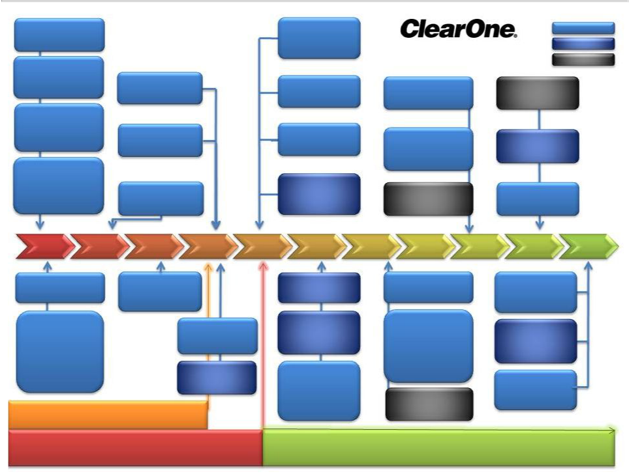

April 2003 | August 2005 | May 2008 | July 2009
CLRO delisted | ClearOne restates | ClearOne adds $1M to | Narsi Narayanan
from NASDAQ | consolidated financial | stock buy-back | appointed VP, Finance
 | statements

January 2013

ClearOne receives

$45M auction-rate

securities settlement

December 2003 | August 2006
ClearOne settles SEC | Shares begin trading
and class action | on OTC Bulletin Board
proceedings; pays $5M
and $1.2M in shares to | August 2006
former shareholders; | August 2006
pays no fine to the SEC | Board authorizes $2M
 | stock buy-back

SEC Investigation

January 2003-July 2006

August 2008

Tender offer to repurchase up to 20% shares outstanding

November 2008

ClearOne awarded
$10.5M in punitive
and compensatory

damages in trade

secret case

July 2009
ClearOne named one of | February 2013
America’s fastest | Board approves
growing small public | increase of stock buy-
companies by Fortune | back to $10M
Small Business
magazine | April 2013
 | ClearOne recoups
November 2009 | ~$500K in legal
ClearOne acquires | expenses
NetStreams

Delisted from NASDAQ CLRO Trades on NASDAQ

April 2003-August 2007 August 2007-Present

November 18, 2013

